[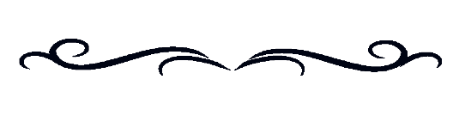](https://www.google.ca/url?sa=i&url=https%3A%2F%2Fclipartion.com%2Ffree-clipart-6878%2F&psig=AOvVaw1AnKjka4wEsVkCN5eooNvq&ust=1604085320219000&source=images&cd=vfe&ved=0CAIQjRxqFwoTCJCc8s_B2uwCFQAAAAAdAAAAABAP)**A PROCLAMATION**

**WHEREAS Indigenous Peoples with disabilities often face unique barriers that impact their ability to fully participate in the social and economic opportunities available in our communities. And**

**WHEREAS we are committed to the ideal of an inclusive society based on respect and understanding, where Indigenous Peoples (First Nations, Métis, Inuit) with disabilities and the significant contributions they provide to our communities, organizations, provinces., territories and country are recognized, celebrated, and valued. And**

**WHEREAS we are committed to upholding and safeguarding the principles outlined in the United Nations Convention on the Rights of Persons with Disabilities (CRPD), including full and effective participation and inclusion in society, equality of opportunity, and the United Nations CRPD International Committee’s recommendation to Canada to proclaim and recognize November each year as Indigenous Disability Awareness Month. And**

**WHEREAS** **we wish to recognize and support Indigenous Disability Canada / British Columbia Aboriginal Network on Disability Society’s (IDC/BCANDS) creation of Indigenous Disability Awareness Month (IDAM) and join governments, urban and rural Indigenous communities, disability organizations, individuals living with disabilities and their families, from across the country and internationally, in recognizing and celebrating these diverse and vital members of our communities.**

**NOW, THEREFORE**, **be it resolved that we,** (type name here)**, do hereby proclaim and declare annually the month of November as:**



**Indigenous Disability Awareness Month**

**Dated this** type date here **day of** type month here**, 2025**

type name / organization name heretype *signature here*

**Name and Title *Signature***

**IDAM 2025**